Lab 2; Verification of Thevenin and Norton Theorem for AC Circuits

Jake D. Karas

U0000008780

EEL3112C: Circuits 2

MM/DD/YYYY

**Objectives:**

The goal of this experiment was to verify Thevenin’s and Norton’s Theorems for AC circuits. This was done by obtaining the Thevenin and Norton equivalent circuits of a given electrical network analytically and experimentallly. A Thevenin circuit contains a voltage source and an impeding component in series with each other and the load of the original circuit. Meanwhile, a Norton circuit consists of a current source and an impeding component in parallel with each other and the original load. These equivalent circuits are useful in power analysis, especially for determining the voltage over, current through, and maximum power transfer to a load.

**Equipment:**

* Voltmeter (Oscilloscope)
* Ammeter (Oscilloscope)
* Ohmmeter (Oscilloscope)
* Resistor x5
$100 Ω$

$43 Ω$

$4.172 Ω (Potentiometer)$

$1 Ω (Shunt)$

$0.0246 Ω (Virtually 0)$

* Inductor
$560 μH$

* Capacitor x4
$94 μF$

$100 μF$

$102 μF$

$220 μF$

* AC Voltage Source (Function Generator)
* Multimeter (Oscilloscope)

**Theory Development:**

Obtaining the Thevenin or Norton theorem analytically requires removing the load of the circuit (between the two “terminals”) and the original voltage or current source. The Thevenin and Norton impedeances - $Z_{Th}$ and $Z_{N}$ respectively - are the same as each other, so both can be found by looking into the circuit via the open terminal and finding the equivalent impedance.

In the case of finding the Thevenin source voltage, $V_{Th}$, all original sources are restored, but the terminals are left open. In the case of the original circuit for this experiment, this turns it into a voltage divider, and as such, the voltage divider rule may be used to obtain $V_{Th}$. With the load now inserted between the new circuit’s terminals, the current through and voltage over the load can now be calculated as $I_{L}=\frac{V_{Th}}{Z_{Th}+Z_{L}}$ and $V_{L}=\frac{Z_{L}}{Z_{Th}+Z_{L}}V_{Th}$.

In a similar manner, the sources are restored once $Z_{N}$ is known for a Norton equivalent circuit. However, one important difference is that this time, the terminals are shorted with a wire rather than left open. For this experiment’s original circuit, this reduces the current throught capacitor 1 to zero, meaning that the Norton source current, $I_{N}$, is a simple Ohm’s Law quotient between the original source voltage and the remaining impedance. As before, the load can then be inserted between the new circuit’s terminals, and the current and voltage through it can be calculated as $I_{L}=\frac{Z_{N}}{Z_{N}+Z_{L}}I_{N}$ and $V_{L}=Z_{L}I_{N}$.

**Methods/Procedures:**

Part 1:

To expedite the process of determining the values of the Thevenin voltage and impedance, Hyperphysics’ AC Thevenin’s Theorem calculator was used to obtain the impedance and source voltage for the Thevenin equivalent physical circuit. After building said circuit with the load in tact between the terminals, the voltage over the load was measured with the oscilloscope, utilizing the source voltage as reference for obtaining the phase angle. This voltage was then divided by the load impedance to determine the current flowing through itself.

Part 2:

Hyperphysics’ AC Thevenin’s Theorem calculate was once again utilized to obtain the Thevenin equivalent impedance, as it is the same value for the Norton equivalent. By utilizing a 1 ohm shunt resistor, the Thevenin source voltage obtained had the same magnitude as the Norton source current, so therefore, the source voltage was set accordingly when constructing the Norton circuit. This time, however, the load voltage and current were extracted by measuring the voltage over the shunt resistor as a 3rd line in the circuit, as it had the same voltage drop as the main and load branches of the circuit.

**Circuit Diagrams:**

Part 1:

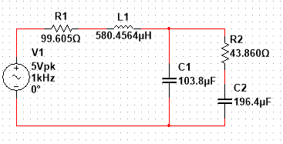

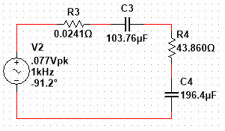

Part 2:

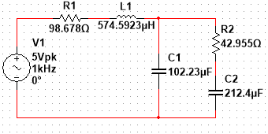

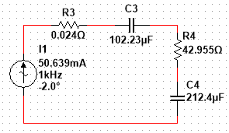

**Results (Theoretical and Experimental):**

Part 1:

Values Used:

* + (Internal Resistance)

$C_{1}=100 μF (103.8 μF)$

$Z_{C1}= -1.533j Ω$

$C_{2}=220 μF (196.4 μF)$

$Z_{C2}= -0.810j Ω$

| Theoretical | | | |
| --- | --- | --- | --- |
|  |  |  |  |
|  |  |  |  |

| Experimental (Multisim) | | | |
| --- | --- | --- | --- |
|  |  |  |  |
|  |  |  |  |

| Experimental (Hardware) | | | |
| --- | --- | --- | --- |
| $Z_{Th}$ | $V_{Th}$ | $I_{L}$ | $V_{L}$ |
| $2.336∠-46^{o} Ω$ | $262 mV pk$ | $11.307 mA$ | $496 mV pk$ |

Part 2:

Values Used:

* + (Internal Resistance)
 $C_{1}=100 μF (102.23 μF)$

 $Z_{C1}= -1.557j Ω$

$C_{2}=220 μF (212.4 μF)$

$Z_{C2}= -0.749j Ω$

$R_{shunt}=1.0 Ω (1.094 Ω)$

+ Is a 3rd parallel line in the circuit.

| Theoretical | | | |
| --- | --- | --- | --- |
|  |  |  |  |
|  |  |  |  |

| Experimental (Multisim) | | | |
| --- | --- | --- | --- |
|  |  |  |  |
|  |  |  |  |

| Experimental (Hardware) | | | |
| --- | --- | --- | --- |
| $Z_{N}$ | $I_{N}$ | $I_{L}$ | $V_{L}$ |
| $1.558∠-89.097^{o} Ω$ | $50.6∠87.7^{o}mA$ | $90∠-84^{o} mA$ | $3.867∠-85.0^{o} V$ |

**Results Analysis and Discussion:**

Significant error has caused the results to vary between the theoretical, simulated, and actual versions of each equivalent circuit. As the most impactful example, the hardware values for $Z_{Th}$ and $Z_{N}$ given by Hyperphysics were different from one another, whereas the theoretical, and likewise the simulated values, were nearly identical between both circuits. This may have been caused by a typo when entering the impedance values on Hyperphysics, potentially even by placing one of the values in the wrong impedance box on the website.

A lesser error that is present is with the phase angle of $I_{N}$ being greater in the physical Norton circuit than its theoretical and experimental counterparts. It means that the actual current would lead the theoretical/simulated current by almost 90 degrees. This may have in turn made the actual load current and voltage different from the calculated and simulated Norton circuits. This was likely caused by assuming the resistor was virtually zero ohms, as there were no resistors in the lab as low as a quarter of an ohm, which was also impossible to achieve with a potentiometer.

The last major form of error that occurred was the load voltage and current varying greatly between all three forms of the Thevenin circuit. However, while the hardware value error was likely caused by Hyperphysics giving incorrect values to work from, the simulated load values were only approximately twice as large in magnitude as they were calculated to be.

**Conclusion:**

Thevenin and Norton equivalent circuits are extremely useful for easily obtaining circuit properties regarding a particular load in addition to simplifying the rest of the circuit into just a couple components, even with AC circuits. However, as the new impedance and source voltage or current tends to be rather low in magnitude, precise components with the required values are often required to replicate a Thevenin or Norton circuit in real life.

Reference:

<http://hyperphysics.phy-astr.gsu.edu/hbase/electric/acthev.html#:~:text=AC%20Thevenin%20Example,therefore%20a%20a%20series%2Dparallel%20combination>